**PROJECT REPORT**

# Employee Management System

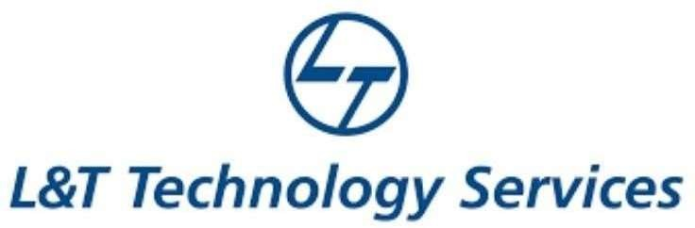

# NAME: - DivyaMadhuri.Tammineni

**TABLE OF CONTENTS**

|  |  |  |
| --- | --- | --- |
| **SERIAL No.** | **CONTENT** | **PAGE No.** |
| 1 | Introduction | 3 |
| 2 | Objective | 3 |
| 3 | Features | 3 |
| 4 | 4 W’s 1H | 4 |
| 5 | SWOT Analysis | 4 |
| 6 | Requirements | 6 |
| 7 | Architecture | 7 |
| 8 | Use case diagram | 8 |
| 9 | Expected results/Outcomes | 9 |

# Introduction

Employee Management system is an application that enables users to create and store Employee Records. The application also provides facilities of a payroll system which enables user to generate Pay slips too. This application is helpful to department of the organization which maintains data of employees related to an organization .

Java is a platform independent language. Its created applications can be used on a standalone machine as well as on distributed network. More over applications developed in java can be extended to Internet based applications.

Thus java was chosen as background to design this application.

# Objective:

In this world of growing technologies everything has been computerized. With large number of work opportunities the Human workforce has increased. Thus there is a need of a system which can handle the data of such a large number of Employees in an organization. This project simplifies the task of maintain records because of its user friendly nature.

# Benefits:

Foster Open Communication.

Constructive Feedback Is Easy.

Create A Smooth Onboarding Process.

Help Employees Develop Skills.

Improve Employee Engagement.

Less Paperwork.

Track Time And Attendance.

Better Employee-Manager Relationship.

# Features

## Saves Productive Time

Smooth Decision Making

Prompt and Accurate Payroll

Happy Workforce

Online Employee Management

Employee Self-Service Portal

# Who:

EMS helps to eliminate the manual process and saves a lot of time and money. This system maintains the professional and personal details of the employees and the company in a safe manner. The employee management system lowers the burden and the pressure on HRs and the business manager.

# What:

 provides with insights into their workforce, and helps them to better plan

and manage work hours to easily control labor costs

and increase productivity

# Where:

Employee management systems are useful for running a smooth organization, especially organizations of scale. It assists HR personnel to keep track of employee information such as salary details, medical information, attendance/leave records, overall performance and more.

# How:

An employee management system is a software, that helps your employees to give their best efforts every day to achieve the goals of your organization. It guides and manages employees efforts in the right direction. It also securely stores and manages personal and other work-related details for your employees.

# SWOT Analysis Strengths

# Weaknesses

* Cash flow is not for particular user
* Better than excel and creating csv for tracking expenses.
* Complete house expense tracking but has no timestamp.

# Opportunities

* Creates awareness about saving and money management
* Allows user to do budgeting in efficient way
* Can plan for upcoming big events with increasing the saving and avoiding extra expenses.

# Threats

* Trend of investing is good for inflation but frequent use can add to changes transaction charges and tax for the wealth created.
* Financial plans needs to be created for better money management.
* Varied daily income should be clearly indicated with reduction of tax as an expense.

# REQUIREMENTS



**High Level Requirements**



|  |  |  |  |
| --- | --- | --- | --- |
| **ID**    HR01 HR02 HR03 HR03 HR04  HR05 | **Description**    New customer can create account Customer can mantain a Balance Customer information can be displayed Customer can pay the bill from e-wallet  Customer can maintain money in account's wallet    The last transaction amount of the custmoer in the store have to be maintained | **Category**  Techinal Technical Technical Techinal technical  Technical | **Status**      TBI TBI TBI TBI  TBI |
| HR06 | Customer can opt for home delivery | Technical | FUTURE |

# Low Level Requirements



|  |  |  |  |
| --- | --- | --- | --- |
| **ID**    LR01    LR02  LR03 LR04 | **Description**    For Each new account a new array cell of structure type have to be created    Balance can be mantanied by creating a structure array each cell holding information of the user and their balance    Customer information can be displayed by printing the structure array    When paying bill the balance attribute is modified and updated | **HRID**  HR01  HR02  HR03 HR04 | **Status**    TBI    TBI  TBI TBI |
| LR05 | The home delivery option cane be implemented by taking the address of the customer | HR06 | FUTURE |

**Architecture:**

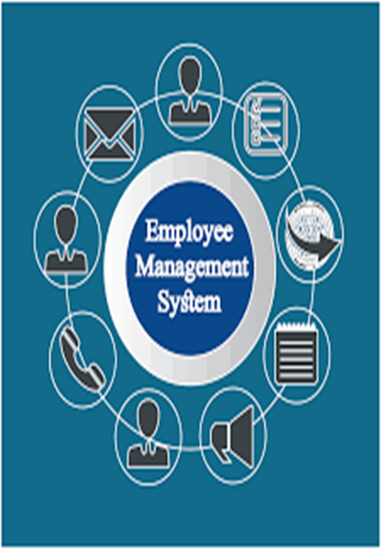

# Use Case Diagram

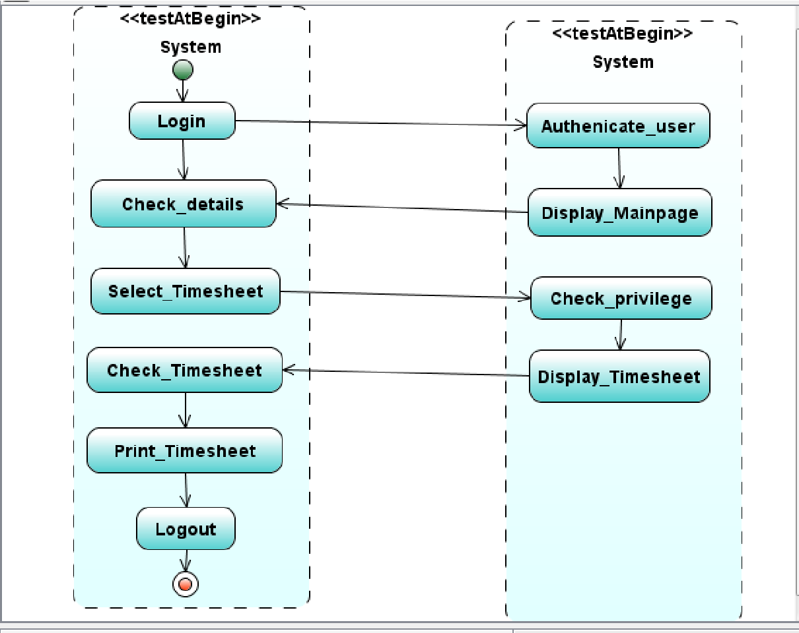

**Output Images:**

